|  |  |
| --- | --- |
| NAME | ABHINAV KUMAR SINGH |
| ROLL NO. | 20IM30032 |

ASSIGNMENT-1( OR LAB )

**Question 1**

Maximize, *Z* = 50*x*1 + 40*x*2

Subject to,

3*x*1 + 5*x*2 ≤ 150 (Assembly Time)

*x*2 ≤ 20 (special Component )

8*x*1 + 5*x*2 ≤ 300 (warehouse space)

*x*1, *x*2 ≥0

**Solution 1**

Model File

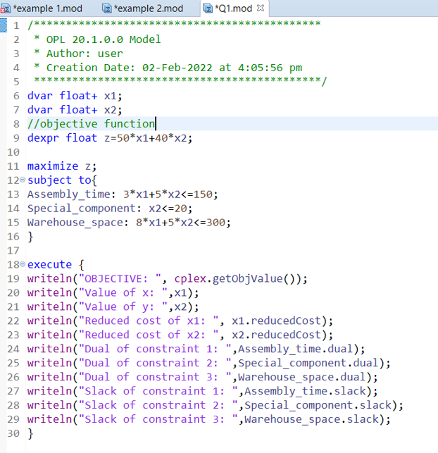

Problem Browser

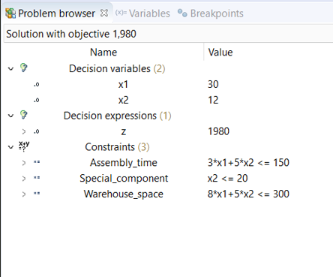

Scripting Log

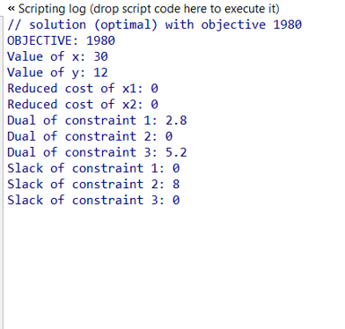

**Question 2**

Minimize, 𝑍=50𝑥1+100𝑥2

Subject to,  7𝑥1+2𝑥2≥28

                   2𝑥1+12𝑥2≥24

                    𝑥1, 𝑥2 ≥ 0

**Solution 2**

 Model File

  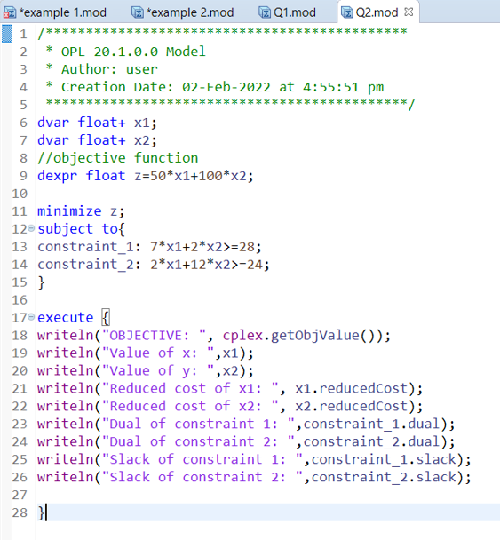

Problem Browser

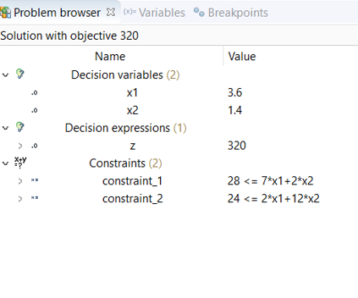

Scripting Log

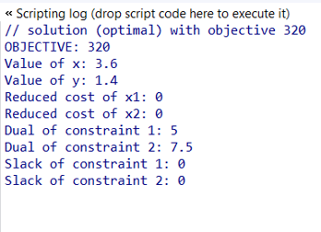

**Question 3**

Maximize 𝑍 = 3𝑥1 + 9𝑥2

subject to,  𝑥1 + 4𝑥2 ≤ 8

                  𝑥1 + 2𝑥2 ≤ 4

                 𝑥1 , 𝑥2 ≥ 0

**Solution 3**

Model File

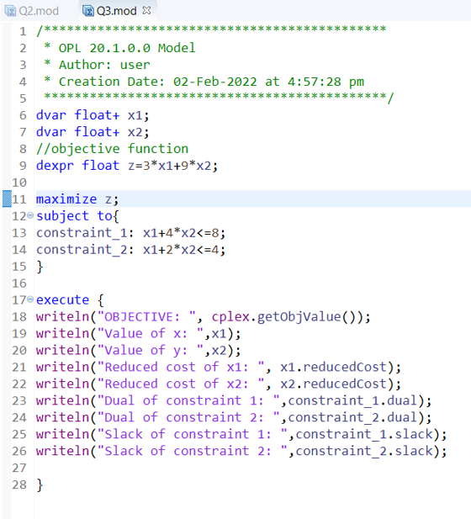

Problem Browser

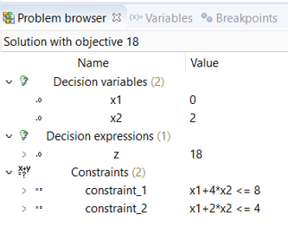

Scripting Log

